DATA ASSIGNMET 2
23F-3106
M.UMAR AFZAAL
TASK 1
#include<iostream>
#include<string>
using namespace std;
struct Node {
char data;
Node* next;
Node(char d) : data(d),next(nullptr){}
};
class Stack {
Node* top;
public:
Stack() : top(NULL){}
void push(char d) {
Node* Newchar = new Node(d);
if (top == NULL) {
top = Newchar;
}
else {
Newchar->next = top;
top = Newchar;
}
}
void pop() {
if (top) {
Node* temp = top;
top = top->next;
delete temp;
temp = NULL;
}
else{
cout << "STACK IS EMPTY:" << endl;
}
}
bool isEmpty() {
return top == nullptr;
}
void display()
{
if (isEmpty()) {
cout << "STACK IS EMPTY:" << endl;
}
Node* current = top;
while (current != nullptr)
{
cout << current->data << " ";
current = current->next;
}
cout << endl;
}
void isPalindrom(string input) {
bool check = false;
for (int i = 0; i < input.size(); i++) {
push(input[i]);
}
for (int i = 0; i < input.size(); i++) {
if (top->data != input[i]) {
check = true;
break;
}
pop();
}
if (check) {
cout << "STRING IS NOT PALINDROM" << endl;
}
else {
cout << "STRING IS PALINDROM" << endl;
}
}
};
int main() {
Stack stack;
string input;
cout << "PLEASE ENTER A STRING" << endl;
getline(cin, input);
stack.isPalindrom(input);
return 0;
}

TASK1 OUTPUT
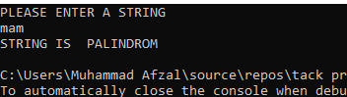
TASK 2
#include <iostream>
#include <string>
using namespace std;
class node1 {
public:
int data;
node1* next;
node1(int data1 = 0) : data(data1) {
next = nullptr;
}
};
class stack2 {
public:
node1* top;
stack2() {
top = nullptr;
}
~stack2() {
node1* current = top;
node1* next = nullptr;
while (current) {
next = current->next;
delete current;
current = next;
}
top = nullptr;
}
void push(int data);
bool isempty();
int pop();
};
int stack2::pop() {
if (isempty()) {
return 1;
}
int val = top->data;
node1* n = top;
top = top->next;
delete n;
return val;
}
void stack2::push(int data) {
node1* n = new node1(data);
n->next = top;
top = n;
}
bool stack2::isempty() {
return top == nullptr;
}

class node {
public:
char data;
node* next;
node(char data) {
this->data = data;
next = nullptr;
}
};

class stack {
private:
node* top;
public:
stack() {
top = nullptr;
}

bool isempty();
bool push(char c);
char pop();
void display();
string infix_to_postfix(string s);
};
void stack::display() {
if (isempty()) {
return;
}
node* current = top;
while (current) {
cout << "Node has data = " << current->data << endl;
current = current->next;
}
cout << endl;
}
char stack::pop() {
if (isempty()) {
cout << "Stack is empty\n";
return '0';
}
char c = top->data;
node* temp = top;
top = top->next;
delete temp;
return c;
}
bool stack::push(char c) {
node* n = new node(c);
n->next = top;
top = n;
return true;
}
bool stack::isempty() {
return top == nullptr;
}

// To check precedence
int precedence(char c) {
if (c == '*' || c == '/' || c == '%') {
return 2;
}
else if (c == '+' || c == '-') {
return 1;
}
else {
return 0;
}
}
bool number(char c) {
return (c >= '0' && c <= '9');
}
string stack::infix_to_postfix(string s) {
string post;
int num = 0;
for (int i = 0; i < s.length(); i++) {
if (s[i] == '(') {
push(s[i]);
}
else if (s[i] == ')') {
while (!isempty() && top->data != '(') {
post += top->data;
post += ' ';
pop();
}
pop();
}
else if (s[i] == '*' || s[i] == '/' || s[i] == '%' || s[i] == '+' || s[i] == '-') {
while (!isempty() && precedence(s[i]) <= precedence(top->data)) {
post += top->data;
post += ' ';
pop();
}
push(s[i]);
}
else if (number(s[i])) {
num = (num * 10) + (s[i] - '0');
}
else if (s[i] == ' ' && num != 0) {
post += std::to_string(num);
post += ' ';
num = 0;
}

cout << "\nAt iteration (" << i + 1 << ") : \n";
cout << "String = " << post << endl;
cout << "Stack = ";
node* temp = top;
while (temp) {
cout << temp->data << " ";
temp = temp->next;
}
cout << endl;
}

if (num != 0) {
post += std::to_string(num);
post += ' ';
}
while (!isempty()) {
post += top->data;
post += ' ';
pop();
}
return post;
}
int evaluate(string post) {
int num = 0;
stack2 s;
for (int i = 0; i < post.length(); i++) {
if (post[i] == '*' || post[i] == '/' || post[i] == '%' || post[i] == '+' || post[i] == '-') {
int n1 = s.pop();
int n2 = s.pop();
int result = 0;
if (post[i] == '*') {
result = n2 * n1;
}
else if (post[i] == '+') {
result = n2 + n1;
}
else if (post[i] == '/') {
result = n2 / n1;
}
else if (post[i] == '-') {
result = n2 - n1;
}
else if (post[i] == '%') {
result = n2 % n1;
}
s.push(result);
}
else if (post[i] == ' ') {
if (num != 0) {
s.push(num);
num = 0;
}
}
else if (number(post[i])) {
num = (num * 10) + (post[i] - '0');
}
}
return s.pop();
}
string reverse(string s) {
string rev;
for (int i = s.length() - 1; i >= 0; i--) {
if (s[i] == ')') {
rev += '(';
}
else if (s[i] == '(') {
rev += ')';
}
else {
rev += s[i];
}
}
return rev;
}
string infix_to_prefix(string s) {
stack st;
s = reverse(s);
s = st.infix_to_postfix(s);
s = reverse(s);
return s;
}
int main() {
string s;
cout << "Enter string = ";
getline(cin, s);
int choice;
bool exit = false;
while (!exit) {
cout << "Enter 1 to convert string to postfix \n";
cout << "Enter 2 to convert string to prefix \n";
cout << "Enter 0 to exit program\n";
cout << "Enter choice = ";
cin >> choice;
if (choice == 1) {
stack st;
string post = st.infix_to_postfix(s);
cout << "Postfix = " << post << endl;
int num = evaluate(post);
cout << "\nPostfix evaluation = " << num << endl;
}
else if (choice == 2) {
string pre = infix_to_prefix(s);
cout << "Prefix = " << pre << endl;
}
else if (choice == 0) {
exit = true;
}
else {
cout << "Invalid input\n";
}
}
return 0;
}

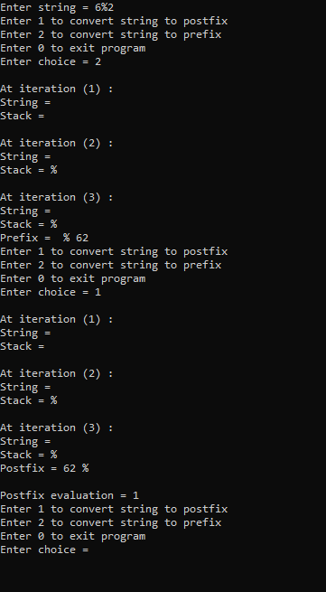

TASK 3
#include <iostream>
#include <cmath>
#include <limits>
using namespace std;
class Node {
public:
int data;
Node* next;
Node(int d) : data(d), next(nullptr) {}
};
class STACK {
Node* head;
int size;
public:
STACK() : size(0), head(nullptr) {}
void push(int d) {
Node* newNode = new Node(d);
newNode->next = head;
head = newNode;
size++;
}
void pop() {
if (head) {
Node* temp = head;
head = head->next;
delete temp;
size--;
}
else {
cout << "STACK IS EMPTY" << endl;
}
}
bool empty() const {
return head == nullptr;
}
int top() {
if (head)
return head->data;
return -1;
}
int getSize() const {
return size;
}
void print() {
if (empty()) {
cout << "EMPTY";
return;
}
STACK tempStack;
while (!empty()) {
int num = top();
tempStack.push(num);
pop();
}
while (!tempStack.empty()) {
cout << tempStack.top() << " ";
push(tempStack.top());
tempStack.pop();
}
}
};
class Tower {
public:
STACK* shelves;
int size;

Tower(int si) {
size = si;
shelves = new STACK[3];
for (int i = size; i > 0; i--) {
shelves[0].push(i);
}
}
~Tower() {
delete[] shelves;
}
bool result() {
return shelves[2].getSize() == size;
}
void makeMove(int source, int dest) {
int srcIdx = source - 1;
int destIdx = dest - 1;

if (shelves[srcIdx].empty()) {
cout << "|| SOURCE SHELF IS EMPTY ||" << endl;
return;
}
if (shelves[destIdx].empty() || shelves[destIdx].top() > shelves[srcIdx].top()) {
shelves[destIdx].push(shelves[srcIdx].top());
shelves[srcIdx].pop();
}
else {
cout << "|| YOU CANNOT PLAY THIS MOVE ||" << endl;
}
}
void playGame() {
int count = 0;
int source, dest;
char choice = 'y';

while (choice == 'y' || choice == 'Y') {
while (!result()) {
cout << "DATA SOURCE (1-3): ";
while (!(cin >> source) || source < 1 || source > 3 || shelves[source - 1].empty()) {
cout << "ENTER CORRECT SHELF NUMBER: ";
cin.clear();
cin.ignore(numeric_limits<streamsize>::max(), '\n');
}
cout << "DATA DESTINATION (1-3): ";
while (!(cin >> dest) || dest < 1 || dest > 3) {
cout << "ENTER CORRECT SHELF NUMBER: ";
cin.clear();
cin.ignore(numeric_limits<streamsize>::max(), '\n');
}
makeMove(source, dest);
count++;
for (int i = 0; i < 3; i++) {
cout << "SHELF " << i + 1 << " = ";
shelves[i].print();
cout << endl;
}
}
if (count > pow(2, size) - 1) {
cout << "YOU CROSSED THE FEWEST MOVES BUT COMPLETED, TRY NEXT TIME!" << endl;
}
else {
cout << "YOU WON THE GAME!" << endl;
}
cout << "DO YOU WANT TO PLAY AGAIN? (y/n): ";
cin >> choice;
count = 0;
if (choice == 'y' || choice == 'Y') {
resetGame();
}
}
}
void resetGame() {
for (int i = 0; i < 3; i++) {
while (!shelves[i].empty()) {
shelves[i].pop();
}
}
for (int i = size; i > 0; i--) {
shelves[0].push(i);
}
}
};
int main() {
int size;
cout << "ENTER NUMBER OF RECORDS: ";
cin >> size;

Tower hanoi(size);
cout << "-----------------------------" << endl;
cout << "- WELCOME TO TOWER OF HANOI -" << endl;
cout << "-----------------------------" << endl;
cout << endl;
cout << " ---------" << endl;
cout << " - RULES -" << endl;
cout << " ---------" << endl;
cout << "\n";
cout << "1. You can only move one stack of records at a time." << endl;
cout << "2. A larger record cannot be placed on top of a smaller record." << endl;
cout << "3. You can only move the top stack of records from a shelf." << endl;
cout << "\n";

cout << "-----------------------------" << endl;
cout << "- WELCOME TO TOWER OF HANOI -" << endl;
cout << "-----------------------------" << endl;
cout << "\n\n";
cout << "||SHELVES||" << endl;
for (int i = 0; i < 3; i++) {
cout << "SHELF " << i + 1 << " = ";
hanoi.shelves[i].print();
cout << endl;
}
hanoi.playGame();
return 0;
}

TASK 3 OUTPUT

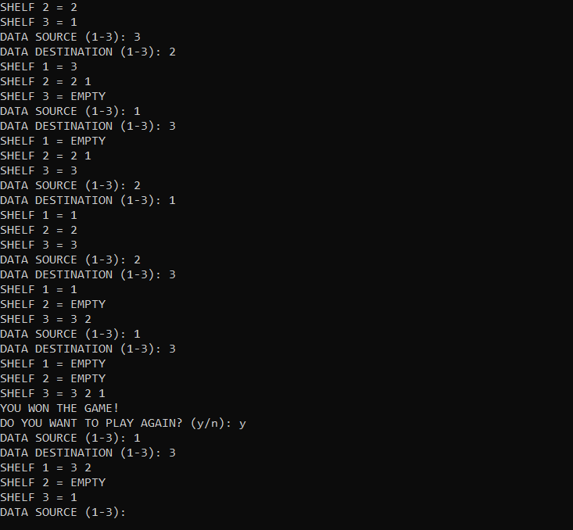
TASK 4

#include<iostream>
#include<string>
using namespace std;
template<typename T>
class CinemaQueue
{
int size;
int front, rear;
T* queue;
public:
CinemaQueue(int size = 0)
{
this->size = size;
front = rear = -1;
queue = new T[size];
}
bool isFull()
{
return (rear + 1) % size == front;
}
bool isEmpty()
{
return front == -1 || rear == -1;
}
void Enqueue(T data)
{
if (isFull())
{

cout << "Full! " << endl;
}
else if (isEmpty())
{
front = rear = 0;
queue[rear] = data;
}
else
{
rear = (rear + 1) % size;
queue[rear] = data;
}
}
void Dequeue()
{
if (isEmpty())
{

cout << "Empty!" << endl;
}
else
{
if (front == rear)
{
front = rear = -1;
}
else
front = (front + 1) % size;

}
}
T getTop()
{
if (isEmpty())
{

cout << "Empty" << endl;
return T();
}

return queue[front];

}

};

template<typename T>
void Input(CinemaQueue <T>* queue, int queuesize, int persons)
{
string name;

for (int i = 0; i < queuesize; i++)
{
cout << "Filling queue " << (i + 1) << " with " << persons << " persons:" << endl;
for (int j = 0; j < persons; j++)
{

cout << "Enter the name of person " << i + 1 << " ";
cin >> name;
queue[i].Enqueue(name);
}

}

cout << endl << " ------------------------------" << endl;
}

template<typename T>
void ProcessQueues(CinemaQueue<T>* queue, int queueSize)
{
int time = 0;
while (!queue[0].isEmpty())
{

cout << "The member at the front is " << queue[0].getTop() << endl;
queue[0].Dequeue();
int i = 0;
while (!queue[i + 1].isEmpty() && i + 1 < queueSize)
{

cout << "I moved queue member " << "(" << i + 1 << ") " << " to queue " << i << endl;
queue[i].Enqueue(queue[i + 1].getTop());
queue[i + 1].Dequeue();
i++;
}
time = time + 2;
}

cout << "The total time taken by ticket collectors to process members is " << time << endl;
cout << " ------------------------------------" << endl;
}

int main() {
int noofqueue;
cout << "Enter the number of queues: ";
cin >> noofqueue;
while (noofqueue < 0) {
cout << "Enter the number of queues: ";
cin >> noofqueue;
}
cout << noofqueue << " queues are created." << endl;

CinemaQueue<string>* ptr = new CinemaQueue<string>[noofqueue];

int numofperson;
cout << "Enter number of persons in each queue:" << endl;
cin >> numofperson;
while (numofperson < 0) {
cout << "Enter number of persons in each queue:" << endl;
cin >> numofperson;
}

for (int i = 0; i < noofqueue; i++) {
cout << "The number of persons in queue " << i + 1 << " is: " << numofperson << endl;
ptr[i] = CinemaQueue<string>(numofperson);
}

Input(ptr, noofqueue, numofperson);
ProcessQueues(ptr, noofqueue);

delete[] ptr;
ptr = NULL;
}
TASK4 OUTPUT
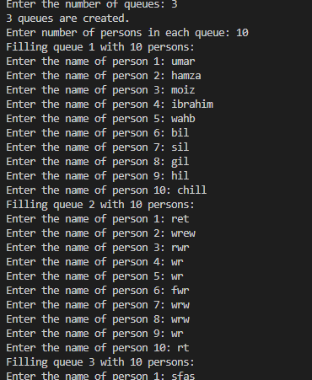

TASK 5
#include <iostream>
using namespace std;
class Deque {
int front, rear;
int maxSize;
int* arr;
public:
Deque() {
cout << "Enter the size of the deque: ";
cin >> maxSize;
arr = new int[maxSize];
front = rear = -1;
}
bool isEmpty() {
return front == -1;
}
bool isFull() {
return (rear + 1) % maxSize == front;
}
void pushBack(int value) {
if (isFull()) {
cout << "Deque overflow! Cannot push value." << endl;
return;
}
if (isEmpty()) {
front = rear = 0;
arr[rear] = value;
}
else {
rear = (rear + 1) % maxSize;
arr[rear] = value;
}
cout << "Value " << value << " pushed to the back." << endl;
}
void pushFront(int value) {
if (isFull()) {
cout << "Deque overflow! Cannot push value." << endl;
return;
}
if (isEmpty()) {
front = rear = 0;
arr[front] = value;
}
else {
front = (front - 1 + maxSize) % maxSize;
arr[front] = value;
}
cout << "Value " << value << " pushed to the front." << endl;
}
void popBack() {
if (isEmpty()) {
cout << "Cannot pop value from deque; it is empty." << endl;
return;
}
cout << "Value " << arr[rear] << " popped from the back." << endl;
if (front == rear) {
front = rear = -1; // Deque is now empty
}
else {
rear = (rear - 1 + maxSize) % maxSize;
}
}
void popFront() {
if (isEmpty()) {
cout << "Cannot pop value from deque; it is empty." << endl;
return;
}
cout << "Value " << arr[front] << " popped from the front." << endl;
if (front == rear) {
front = rear = -1; // Deque is now empty
}
else {
front = (front + 1) % maxSize;
}
}

~Deque() {
delete[] arr;
arr = nullptr;
}
};
int main() {
Deque d;
d.pushFront(25);
d.pushFront(88);
d.pushBack(122);
d.pushBack(50);
d.popBack();
d.popFront();
d.popBack();
d.popFront();
d.popFront();
return 0;
}

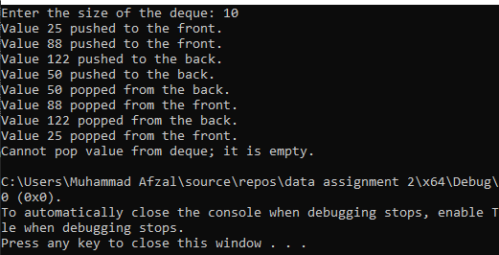

TASK 6
#include <iostream>
#include <string>
using namespace std;
class Node {
public:
char data;
Node* next;
Node(char data) {
this->data = data;
this->next = NULL;
}
};
class Stack {
Node* Top;
public:
Stack() {
Top = NULL;
}
void push(char a) {
Node* temp = new Node(a);
temp->next = Top;
Top = temp;
}
void pop() {
if (isEmpty())
return;
Node* temp = Top;
Top = Top->next;
delete temp;
}
bool isEmpty() {
return Top == NULL;
}
char top() {
if (isEmpty())
return '\0';
return Top->data;
}
};
class NodeQueue {
public:
char data;
NodeQueue* next;
public:
NodeQueue(char d) {
data = d;
next = NULL;
}
};
class Queue {
NodeQueue* front;
NodeQueue* rear;
public:
Queue() {
front = rear = NULL;
}
bool isEmpty() {
return front == NULL;
}

void push(char x) {
NodeQueue* newnode = new NodeQueue(x);
if (isEmpty()) {
front = rear = newnode;
}
else {
rear->next = newnode;
rear = newnode;
}
}
void pop() {
if (isEmpty()) {
return;
}
else {
if (front == rear) {
delete front;
front = rear = NULL;
}
else {
NodeQueue* curr = front;
front = front->next;
delete curr;
}
}
}
char top() {
if (isEmpty()) {
return '\0';
}
else {
return front->data;
}
}
};
void inputQueueAndStack(Queue& q, string& characters, Stack& s) {
int len = characters.length();
for (int i = 0; i < len; i++) {
q.push(characters[i]);
s.push(characters[i]);
}
}
bool isPalindrome(Stack& s, Queue& q) {
Queue temp = q;
while (!s.isEmpty() && !temp.isEmpty()) {
if (s.top() != temp.top()) {
return false;
}
s.pop();
temp.pop();
}
return true;
}
int main() {
cout << "ENTER THE STRING: ";
string characters;
cin >> characters;
Queue q;
Stack s;
inputQueueAndStack(q, characters, s);
bool palindrom = isPalindrome(s, q);
if (palindrom) {
cout << "THE GIVEN STRING: \"" << characters << "\" IS A PALINDROME!!" << endl;
}
else {
cout << "THE GIVEN STRING: \"" << characters << "\" IS NOT A PALINDROME!!" << endl;
}
return 0;
}

TASK 6 OUTPUT
